The Decline of the Tobacco Industry in Brown County, Ohio
A Literature Review

Presented by

Joshua Cooper
Shawnee State University

Author Note
This paper was prepare for and presented at the Ohio River Valley Historical Conference 10/17/2014
Abstract
Burley tobacco in Brown County, Ohio was once considered a cash crop. In the last 30 years tobacco production has been on the decline. There are many contributing factors to this decline in tobacco production. This literature review examines the trends that have affected the production of burley tobacco in Brown County, Ohio. This paper analyzes the effect of FDA regulations, social pressure, as well as climate and market conditions. Finally, this paper calls to attention the alternatives to tobacco production, the effects of technology and the possibility for a revival of the tobacco industry in Brown County, Ohio.
A History of Tobacco Production
Upon his arrival in the New World in 1492, Christopher Columbus discovered natives using tobacco in the same ways we do today. By the 16th century, tobacco was being prescribed in England for all manner of ailments from a person’s waist up to their head. In 1612, John Rolfe planted the first tobacco crop in the Jamestown settlement. This crop became America’s first export in 1613. It is said that had it not been for the tobacco plant, Jamestown would have been another in a long line of failed British settlements. Over the next century the value of tobacco would increase exponentially. In fact, tobacco was so valuable in the late 1700’s that it allowed Benjamin Franklin to negotiate a loan from the French government, using tobacco as collateral. Tobacco would become primary source of funding for the Continental Congress and the American Revolution (Arnold, 2014).
In the late 1780’s, thousands of settlers traveled to Ohio and brought with them tobacco seeds. The crop would spread throughout the Ohio River Valley into Kentucky and Tennessee. On those early farms Ohio farmers were growing a yellow leaf tobacco known as eastern Ohio export. This strand of broad leaf tobacco was grown exclusively in the area. “Old Hillside”, as the farmers called it, reached its height from between 1840-1880. During this time, Cincinnati would develop into the nation’s number four exporter. The tobacco trade exploded during the Civil War, increasing the demand of hogsheads from 6,000 to 50,000 per year. By 1880, Cincinnati had become major center of tobacco distribution, requiring over 100,000 hogsheads per year. The boom in the Cincinnati market was fueled by the discovery of a new strain of burley tobacco (Duffin, 1982).
In the spring of 1864, George Webb, a tenant farmer in Brown County, found himself short of seed. Webb crossed the Ohio River to Bracken County, Kentucky and purchased some seed. Webb believed he had purchased a variety known as Little Burley. Webb planted the seed in the hilly soil near Higginsport, Ohio. Upon transplanting the plants, Webb noticed white and yellow seedlings. Webb instantly thought the plants were diseased but being hard pressed for transplants, Webb used the plants to fill his fields. The light colored plants showed little growth over the next couple weeks as their roots began to take hold. Once those roots took hold, the plants grew rapidly. The plants were ripe two weeks before the other variety and were very large (Killebrew, 1840). The following year Webb planted the same seeds. Strangely the plants were identical to the previous year. Intrigued, Webb cultivated the plants. The results were 1,000 cream colored plants. Farmers from around the country traveled to Brown County to see the new variation of the Burley plant called White Burley (Duffin, 1982). In 1871, Brown County ranked among Ohio counties in acres planted (3,251) and third in pounds produced (2,828,422) (Ohio Department of Agriculture, 1871). In 1881, James Bonsack invented the first cigarette-making machine. The machine could produce 120,000 cigarettes per day and allowed cigarettes to grow in popularity. Bonsack partnered with James Duke to create the first cigarette factory. In its first year the factory produced over 10 million cigarettes and in five years produced over 1 billion. Duke and his father formed the American Tobacco Trust and would dominate the tobacco industry. The American Tobacco Trust is credited with manufacturing the first brand of cigarettes, Duke of Durham. The blend of tobacco used in these cigarettes was 33% white burley tobacco (Jacobs, 1997).
In 1866, Webb’s farm produced nearly 20,000 lbs of White Burley. In 1867, the leaf won prizes at the St. Louis Fair and brought $58 per pound. In the same year, White Burley was ranked third of 10 in all classes of tobacco at the Cincinnati Tobacco Fair. By 1879, White Burley was the most popular type of tobacco among farmers in Southern Ohio, who produced over 11 million pounds that year. Around this time R.J. Reynolds, famous for Reynolds Wrap Aluminum Foil, began manufacturing chewing tobacco. Tobacco manufacturers also preferred White Burley. The leaf, when cured, was extraordinarily dry and could absorb any amount of liquid flavoring. White Burley was used in the manufacturing of pipe and plug tobacco. A major contributor to the success of Southern Ohio tobacco was Gen. Ulysses S. Grant. Grant was rarely seen without a cigar and it is rumored that he smoked over 30 cigars a day. During his service Grant was sent over 41,000 cigars by the American people, including 11,000 sent from President Lincoln (Duffin, 1982).
At the turn of the century, Ohio farmers were producing over 75 million pounds of tobacco. Sadly, tobacco prices were driven down by the American Tobacco Trust. The low prices sparked an intense period of unrest in the tobacco growing states of Kentucky and Tennessee. By 1906, the group had formed a militia known as the “Night Riders”. The group’s intent was to intimidate local farmers and force them to join the fight against the American Tobacco Trust after a boycott of the burley tobacco crop. The members of this militia would ride under the cover of darkness wearing black hoods and white sashes. Eventually the violence would lead the National Guard to respond and end the raids after nearly a decade of terror (Museums of Historic Hopkinsville-Christian County, 2013). In 1911, the American Tobacco Trust was dissolved into four new companies: Ligget & Myers Tobacco Co., P. Lorillard Co., R.J. Reynolds Tobacco Co., and the American Tobacco Co. Burley production would continue to rise however, until 1919, when farmers planted over 25,000 acres (Ohio Department of Agriculture, 2007). The tobacco marketplace began to change. Buyers, wanting to inspect their purchases, preferred to visit the auction markets of Brown County, in the towns of Ripley and Georgetown. Ripley would become the premier auction site in Southern Ohio. The auction atmosphere provided a spike in tobacco prices but the end of World War I prices dropped for 34 cents per pound to 13 cents per pound. This was mostly due to a poor quality of leaves. Prices would rebound, only to drop again during the Great Depression (Duffin, 1982).
The Cigarette
The cigarette did not become popular until the beginning of the 20th century. In 1901, 3.5 billion cigarettes were sold in the United States. In, 1902 Phillip Morris began marketing the Marlboro brand. During this time the first glimpses of tobacco resentment was evident in a small scale anti-tobacco campaign. Tennessee, a major grower of burley tobacco, placed a ban on cigarette sales. Despite this campaign, R.J. Reynolds began to market Camel brand cigarettes in an attempt to meet the demand of the populace (Boston University Medical Center, 1999). During WWI cigarettes were so popular that US troops were provided with cigarette rations. Many tobacco companies prospered from both government revenue and new advertizing campaigns. By 1920, per capita cigarette consumption had risen to 477 cigarettes per year. By 1930, per capita cigarette consumption increased to 977 cigarettes per year. During WWII, President Roosevelt makes tobacco a protected crop and manufacturers send millions of free cigarettes to GI’s. A tobacco shortage ensues. By 1944, over 300 billion cigarettes were being manufactured each year. Nearly 75% of these cigarettes were shipped to GI’s overseas. By the end of the war cigarette sales were at an all-time high (Borio, 2003).
Brown County, Ohio
Brown County has been a leader in tobacco production since the discovery of White Burley in 1864. Since that time White Burley has become the most commonly grown tobacco in the world. Brown County lies in the heart of the White Burley district along the banks of the Ohio River. The soil here is rich in phosphoric acid due the numerous limestone deposits. The presence of this natural fertilizer and the overall strength of the soil composition make Brown County ideal for growing this valuable weed (Killebrew, 1840).
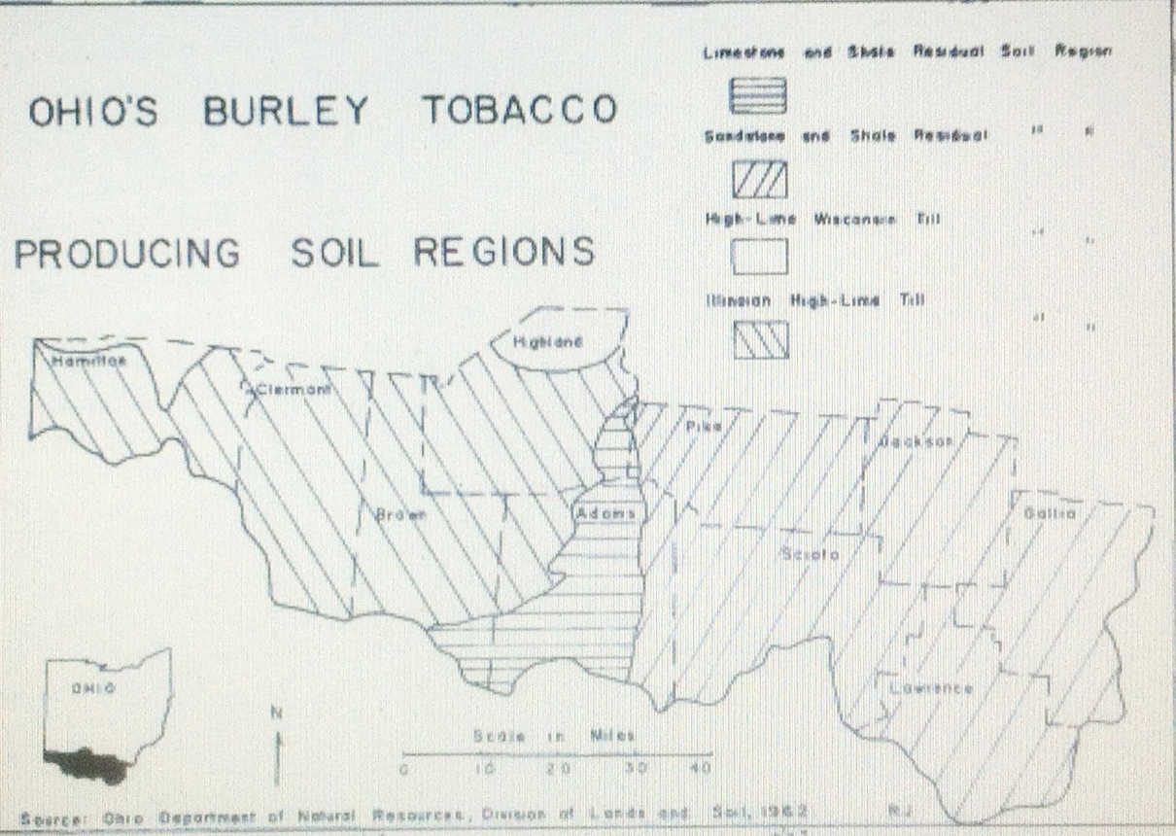
The topography of Brown County limits farming options. In areas along the Ohio River, lack of pasture limits the size of cattle and wheat farms. The eroded hillsides make it difficult to plant and harvest large amounts of any crop. Tobacco was the most profitable crop per acre. The greatest concentration of burley tobacco farms lies in Brown and Adams Counties. The burley tobacco grown in Brown County became increasingly important during WWI. 90% of Ohio’s burley crop is used in the manufacturing of cigarettes. In 1966, the burley tobacco allotment acreage in Ohio was 7,933 acres. Of those allotments, Brown County farms accounted for over 31%. Brown County tobacco farms were also the largest, averaging 1.15 acres per allotment, making Brown County the leading producer of burley tobacco in the state. Of the $13,026,000 dollars generated by Brown County farms in 1966, $3,647,280 was from tobacco sales, solidifying tobacco as Brown County’s cash crop (Jencks, 1972).
Brown County was not only involved in the production of burley tobacco. Ripley, Ohio was founded on the banks of the Ohio River. Ripley soon became a major port for pork and tobacco, second only to Cincinnati. One of the first loose leaf markets was opened in Ripley in 1916. The loose leaf auction was a place where manufacturers could inspect crops and select the finest leaves for their product. The success of loose leaf markets lead to a decrease in revenue in major markets, like Cincinnati and Louisville. By 1935, Ripley was the premier auction center in Ohio (Arnold, 2014).
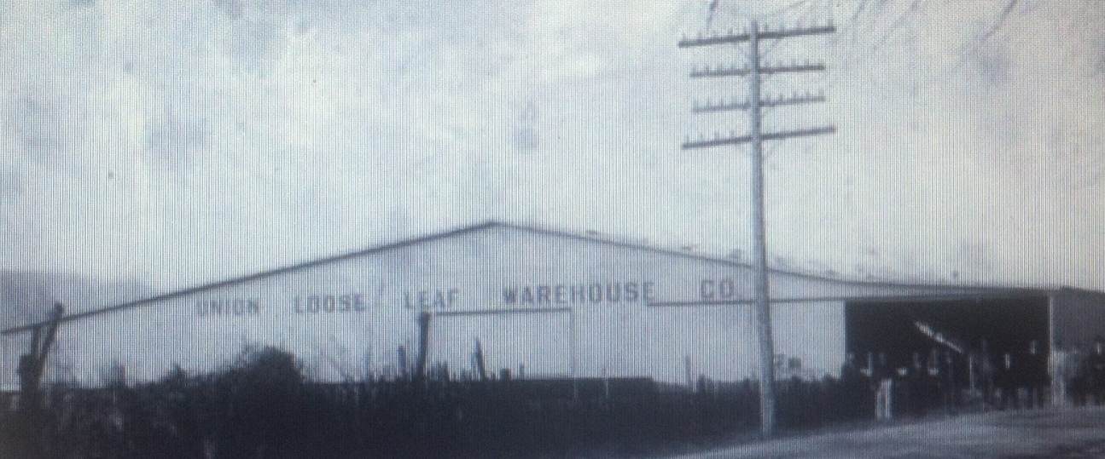
The three tobacco markets in Ripley, Union, O-K and Independent, drew visitors to Brown County from all over the world. R.J. Reynolds, American Tobacco and Ligget-Myers were frequent visitors to the area and brought with them deep pockets. The money generated by tobacco influenced every aspect of Brown County life, most notably the county flag. Designed by a pair of fourth grade students in 1953, the flag features a tobacco plant with light colored leaves, a tribute to the importance of White Burley (Haitz & Haitz, 2006).

The Decline of Brown County’s Tobacco Industry
Today, the Brown County tobacco industry is but a shell of itself. Echoes of the auctioneers call can still be heard in Ripley, but the town that was once the center of the tobacco market is now a patchwork of flea markets and antique stores. The production of burley tobacco in Brown County has dwindled from over 2,500 acres in 1967, to less than 300 acres today. Revenue from tobacco sales has also dropped tremendously from over $3.5 million in 1967 to
There are very few tobacco farms that are larger than five acres (Arnold, 2014). There are many contributing factors to the decline of the tobacco industry in Brown County. In 1964, the US Surgeon General first publicized the dangers of tobacco use. Luther L. Terry M.D., acting US Surgeon General, released a report linking tobacco use to lung cancer and laryngeal cancer in men, lung cancer in women and chronic bronchitis. This would be the first step in a 40 year battle against tobacco. Two laws, the Federal Cigarette Labeling and Advertising Act of 1965 and the Public Health Cigarette Smoking Act of 1969, banned cigarette advertising on television and radio, required a health warning on cigarette packages and called for an annual report on the health consequences of smoking. The creation of the National Clearinghouse for Smoking and Health lead to public anti-smoking advertisements, state programs to reduce tobacco use and the dissemination of research related to tobacco use. Due to these actions, nearly half of all adults who once smoked have ceased. Still, 45 million Americans still smoke today (Center for Disease Control, 2009).
Terry was not the only Surgeon General to wage a war on smoking. C. Everett Koop, US Surgeon General from 1982 to 1989, is credited with being the most determined crusader against tobacco in US history. Appalled by the advertising practices of the tobacco industry, Koop was determined to warn both smokers and non-smokers of the dangers of tobacco. In his first year as Surgeon General, 400,000 Americans died from smoking related complication. This number was greater than the sum of all alcohol, illegal drug and automobile related deaths. Koop released reports that related tobacco to cancer of the lung, oral cavity, larynx, esophagus, stomach, bladder, pancreas, and kidneys. Koop also showed that smoking lead to heart disease and was more dangerous than exposure to asbestos or coal dust. In 1986, Koop succeed in placing specific risks on tobacco products including the dangers of heart disease, lung cancer and birth defects. Koop sparked the American anti-smoking movement and fought for the rights of non-smokers to breathe smoke free air (US National Library of Medicine, 2012).
Anti-smoking publications are not the only measures that the U.S. government has taken to stop tobacco production. In 2005, Congress passed a corporate-tax bill the allotted over $10 billion for tobacco farm quota buyouts. This marked the end of the tobacco price-support program put in place by the New Deal that inflated tobacco prices to above market levels. The quota program was a limit on the amount of tobacco, in pounds, a farmer could send to market. Tobacco quotas were tightly regulated. Tobacco must be grown in the county that held the quota. If a farmer wished to farm tobacco had to obtain a quota through inheritance, land purchase, or lease. Prices for tobacco at the time of the buyout were $1.50 per pound. The quota buyout paid quota owners $7 per pound, tobacco producers $3 per pound and owner/producers $10 per pound (Pasour, 2005).
After the termination of the price-support program and tobacco-quotas any individual who wanted to produce tobacco was able to if they held a contract with a tobacco company. This act put the price controlling power in the hands of the tobacco companies. The appearance of tobacco contracts made the tobacco markets of Ripley, Ohio obsolete. The last market in Ripley closed its doors nearly ten years ago and with it the economic stimulus it provided. Prices fell and production declined. The profitability of tobacco was in a free fall. (Arnold, 2014).
The falling profitability only increased the economic strain put on the tobacco farmers of Brown County. With profit margins dwindling, fewer and fewer farmers could afford the help needed to cultivate a large yield. Most modern crops can now be planted, cultivated and harvested by machine. This allows one man to do the work of many. Unlike wheat, which requires only 3 man hours per acre, burley tobacco requires over 250 hours per acre. 350,000 of the tiny seeds must be planted and covered. When the plants sprout the must be transplanted by hand, sometimes 7,000 plants per acre (Ohio Tobacco Museum, 1988).
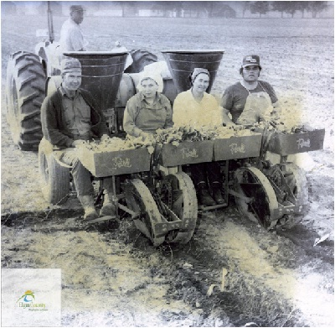
As the plants grow, small shoots must be trimmed to promote leaf growth. As the plant blooms, the flowers must be trimmed to further promote growth. Ripe plants are cut and speared on a stick in the field. Sticks of tobacco are then brought to the curing barn and hung to air cure. When pliable, the leaves are stripped from their stalks and pressed into bales or tied into hands (Ohio Tobacco Museum, 1988). The combined difficulties in tobacco farming and securing a growing contract from a tobacco company have caused many Brown County farmers to abandon the crop that built their region (Arnold, 2014).
Conclusion
The tobacco industry in Brown County has been forever impacted by market changes, government regulations and poor economic conditions. In 2011, only 16,000 acres were harvested in Ohio (National Argricultural Statistics Service, 2011). It can be speculated that the improvements in farming technology have had an impact on the desire to farm tobacco in Brown County. Many farmers have turned to alternative crops such as strawberries and grapes that require similar environmental conditions. There is a sentiment around Brown County that tobacco could make a comeback in the area. The use of tobacco in e-cigs and fringe medicine could provide new markets for tobacco farmers. Despite these sentiments, the fact remains that the tobacco industry in Brown County is but a shadow of its former self. The economic impact on the region has been great but the proud inhabitants of Brown County will find a way to rebound and prosper again.

References
Arnold, J. (2014, 10 11). President, Ohio Tobacco Museum . (J. Cooper, Interviewer)
Borio, G. (2003). Tobacco Timeline. Retrieved October 1, 2014, from Tobacco.org: http://archive.tobacco.org/resources/history/tobacco_history20-1.html
Boston University Medical Center. (1999, August 31). The History of Tobacco. Retrieved October 1, 2014, from University of Dayton: http://academic.udayton.edu/health/syllabi/tobacco/history.htm#industry
Center for Disease Control. (2009, July 6). History of the Surgeon General's Reports on Smoking and Health. Retrieved October 1, 2014, from cdc.gove: http://www.cdc.gov/tobacco/Data_statistics/sgr/history/index.htm
Duffin, A. (1982, May 6). Ohio's Tobacco Heritage. Tobacco Institute.
Haitz, G., & Haitz, L. (2006). Brown County. Charleston: Arcadia .
Jacobs, M. (1997). From the First to Last Ash. Retrieved 10 1, 2014, from healthliteracy.worlded.org: http://healthliteracy.worlded.org/docs/tobacco/Tobacco.pdf
Jencks, W. R. (1972). Ohio's Burley Tobacco Agriculture : a Primary Regional Cash Crop. Ohio Journal of Science , 285-291.
Killebrew, J. (1840). White Burley Tobacco and Its Culture. Fertilizer Manufacturers Association.
Museums of Historic Hopkinsville-Christian County. (2013). A Short History of the Tobacco War. Retrieved 10 1, 2014, from Tobacco War Pilgrimage: http://tobaccowarpilgrimage.com/history/
National Argricultural Statistics Service. (2011). Ohio Farm Income. USDA.
Ohio Department of Agriculture. (2007). 2007 Annual Report. Ohio Department of Agriculture.
Ohio Department of Agriculture. (1871). Ohio Agricultural Report .
Ohio Tobacco Museum. (1988). The Tobacco Farming Process. Ripley, Ohio, USA: Ohio Historical Society.
Pasour, E. (2005, Februaru 1). The Tobacco-Quota Buyout: More Legal Plunder. The Freeman .
US National Library of Medicine. (2012). The C. Everett Koop Papers. Retrieved October 1, 2014, from Profiles in Science: http://profiles.nlm.nih.gov/ps/retrieve/Narrative/QQ/p-nid/85

